**Table of Contents**

### Page No.

### Chapter 1. Introduction

1. Introduction to the System 4
2. Problem Definition 4
3. Aim 4
4. Objective 4
5. Goal 5
6. Need of System 5

### Chapter 2. Hardware and Software requirement

1. Introduction 7
2. System environment 7
3. Software requirement 8
4. Hardware requirements 8

### Chapter 3. System Analysis

1. Purpose 9
2. Project Scope 9
3. Existing System 9
4. Proposed System 9
5. System Description 10

### [Chapter 4.Implementation issues](#chap 8)

1. Python 11
2. HTML 12
3. Cascading style sheet(CSS) 13\
4. Sqlite 14

**Chapter 5. System Design**

1. Introduction 21
2. Conceptual Design 22
3. ER-Diagram 23
4. Logical Design 23
5. Physical Design 24
6. Data Flow Diagram of **“Online Home Services” 24**

### [Chapter 6.User Screens](#chap 8) 25-32

### [Chapter 7.Coding](#chap 8) 33-113

[**Chapter 8. Conclusion**](#chap 9)

1. Features of “**Online Home Services**” 114
2. Benefits Accrued from “**Online Home Services**” 114
3. Limitations of “**Online Home Services**” 115

Bibliography

**CHAPTER # 1**

**Introduction**

*Contents:*

* Introduction
* Problem Definition
* Aim
* Objective
* Goal
* Need of System

**Introduction to the System:**

This Online Home Services project deals with an online system designed for booking serviceman (electrician, carpenter, plumber, painter etc) as per the requirements of the customers at their convenience.

The current system is manual and it is time-consuming. It is also cost-ineffective, and the average return is low and diminishing.

# 

**Objective:**

This software helps user to find serviceman profile and contact them or either click on book now button, after clicking on book now button, serviceperson will immediately contact the user.

**Goal:**

* The project is basically targeted at those people who would like online services.
* To make a database that is consistent, reliable and secure.
* To provide correct, complete, ongoing information.
* To develop a well-organized information storage system.
* To make good documentation so as to facilitate possible future enhancements.

**Need of the System:**

There is always a need of a system that will help users to find home servicepersons in our city and information of their charges per hour.

**CHAPTER # 2**

**Hardware and Software Requirements**

**Hardware and Software Specification**

**Software Requirements:**

* Technology: Python Django
* IDE : Pycharm/Atom
* Client Side Technologies: HTML, CSS, JavaScript , Bootstrap
* Server Side Technologies: Python
* Data Base Server: Sqlite
* Operating System: Microsoft Windows/Linux

**Hardware Requirements:**

* Processor: Pentium-III (or) Higher
* Ram: 64MB (or) Higher
* Hard disk: 80GB (or) Higher

**CHAPTER # 3**

**System Analysis**

*Contents:*

##### Purpose

* Project Scope
* Existing System
* Proposed System
* System Overview

### Purpose:

The purpose of this project is to give a platform to the home serviceman to upload their full profile, by which users can search the serviceman in her city easily.

**Project Scope:**

The project has a wide scope, as it is not intended to a particular organization. This project is going to develop generic software, which can be applied by any businesses organization. More over it provides facility to its users. Also the software is going to provide a huge amount of summary data.

**Proposed System:**

The Online Home Services system is available in the market that can serve serviceman to upload their full profile online and this project help users to easily find serviceman and book them.

**System Overview:**

The key features required in the system are as follows:

**Admin Modules :**

**Manage Servicemens :** By Using this software admin can easily manage servicemen , i.e. Admin can verify the servicemen is good or fake by seeing its profile information , admin can also able to delete the servicemen account.

**Manage Users**

**Manage Bookings**

**Servicemen Modules :**

Create Profile/Edit Profile

View Bookings

**User Modules :**

Search Servicemen

View Servicemen Profiles

Book Servicemen

**CHAPTER # 4**

**Implementation issues**

**FrontEnd (Language Used) :**

HTML

CSS

Javascript

**BackEnd:**

Sqlite (Database)

Python (Server Side Language)

**Python**

Python is a widely used general-purpose, high level programming language. It was initially designed by Guido van Rossum in 1991 and developed by Python Software Foundation. It was mainly developed for emphasis on code readability, and its syntax allows programmers to express concepts in fewer lines of code.

Python is a programming language that lets you work quickly and integrate systems more efficiently.

Python is dynamically typed and garbage-collected. It supports multiple programming paradigms, including procedural, object-oriented, and functional programming. Python is often described as a "batteries included" language due to its comprehensive standard library.

**HTML**

HTML (Hypertext Markup Language) is the set of markup symbols or codes inserted in a file intended for display on a World Wide Web browser page. The markup tells the Web browser how to display a Web page's words and images for the user. Each individual markup code is referred to as an element (but many people also refer to it as a tag). Some elements come in pairs that indicate when some display effect is to begin and when it is to end.

**CASCADING STYLE SHEET (CSS)**

Cascading Style Sheets (CSS) are a collection of rules we use to define and modify web pages. CSS are similar to styles in Word. CSS allow Web designers to have much more control over their pages look and layout. For instance, you could create a style that defines the body text to be Verdana, 10 point. Later on, you may easily change the body text to Times New Roman, 12 point by just changing the rule in the CSS. Instead of having to change the font on each page of your website, all you need to do is redefine the style on the style sheet, and it will instantly change on all of the pages that the style sheet has been applied to. With HTML styles, the font change would be applied to each instance of that font and have to be changed in each spot.

CSS can control the placement of text and objects on your pages as well as the look of those objects.

HTML information creates the objects (or gives objects meaning), but styles describe how the objects should appear. The HTML gives your page structure, while the CSS creates the “presentation”. An external CSS is really just a text file with a .css extension. These files can be created with Dreamweaver, a CSS editor, or even Notepad.

The best practice is to design your web page on paper first so you know where you will want to use styles on your page. Then you can create the styles and apply them to your page.

**Javascript**

JavaScript is a programming language commonly used in web development. It was originally developed by Netscape as a means to add dynamic and interactive elements to websites. While JavaScript is influenced byJava, the syntax is more similar to C and is based on ECMAScript, a scripting language developed by Sun Microsystems.

JavaScript is a client-side scripting language, which means the source code is processed by the client's web browser rather than on the web server. This means JavaScript functions can run after a webpage has loaded without COMMUNICATING with the server. For example, a JavaScript function may check a web form before it is submitted to make sure all the required fields have been filled out. The JavaScript code can produce an error message before any information is actually transmitted to the server.

Like server-side scripting languages, such as PHP and ASP, JavaScript code can be inserted anywhere within the HTML of a webpage. However, only the output of server-side code is displayed in the HTML, while JavaScript code remains fully visible in the source of the webpage. It can also be referenced in a separate .JS file, which may also be viewed in a browser.

**Django**

Django is a web application framework written in Python programming language. It is based on MVT (Model View Template) design pattern. The Django is very demanding due to its rapid development feature. It takes less time to build application after collecting client requirement.

This framework uses a famous tag line: **The web framework for perfectionists with deadlines.**

**CHAPTER # 5**

**System Design**

*Contents:*

* Use case diagram
* Class Diagram
* Activity Diagram
* Sequence Diagram
* Data flow diagram

**Use Case Diagram:**

* Use case diagram consists of use cases and actors and shows the interaction between them. The key points are:
* The main purpose is to show the interaction between the use cases and the actor.
* To represent the system requirement from user’s perspective.
* The use cases are the functions that are to be performed in the module.

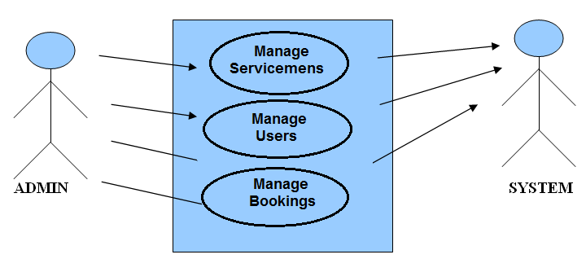

**Use Case Diagram between ADMIN and SYSTEM:**

Fig.5.1

**Feedback**

Fig.5.2

**SYSTEM**

**USER**

**Use Case Diagram between USER and SYSTEM:**

**Sequence Diagram For Administrator:-**

**Administrator**

**Success:hide()**

**Login**

**Application**

**Database**

**Login**

**:Request**

**:Validate()**

**:executeQuery()**

**Response**

**Show Result**

**Failed:show()**

Fig.5.4

**Sequence Diagram For User:-**

**Success:hide()**

**User**

**Login**

**Application**

**Database**

**Login**

**:Request**

**:Validate()**

**:executeQuery()**

**Response**

**Show Result**

**Failed:show()**

**:**

Fig.5.5

**Activity Diagram - User**

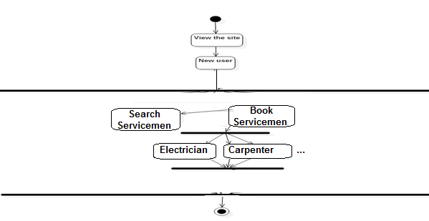

**Data Flow Diagram**

A Data Flow Diagram (DFD) is a graphical representation of the "flow" of data through an Information System. A data flow diagram can also be used for the visualization of Data Processing. It is common practice for a designer to draw a context-level DFD first which shows the interaction between the system and outside entities. This context-level DFD is then "exploded" to show more detail of the system being modeled.

A DFD represents flow of data through a system. Data flow diagrams are commonly used during problem analysis. It views a system as a function that transforms the input into desired output. A DFD shows movement of data through the different transformations or processes in the system.

Dataflow diagrams can be used to provide the end user with a physical idea of where the data they input ultimately has an effect upon the structure of the whole system from order to dispatch to restock how any system is developed can be determined through a dataflow diagram. The appropriate register saved in database and maintained by appropriate authorities.

Data Flow Diagram Notation

Function

File/Database

Input/output

Flow

**DFD**

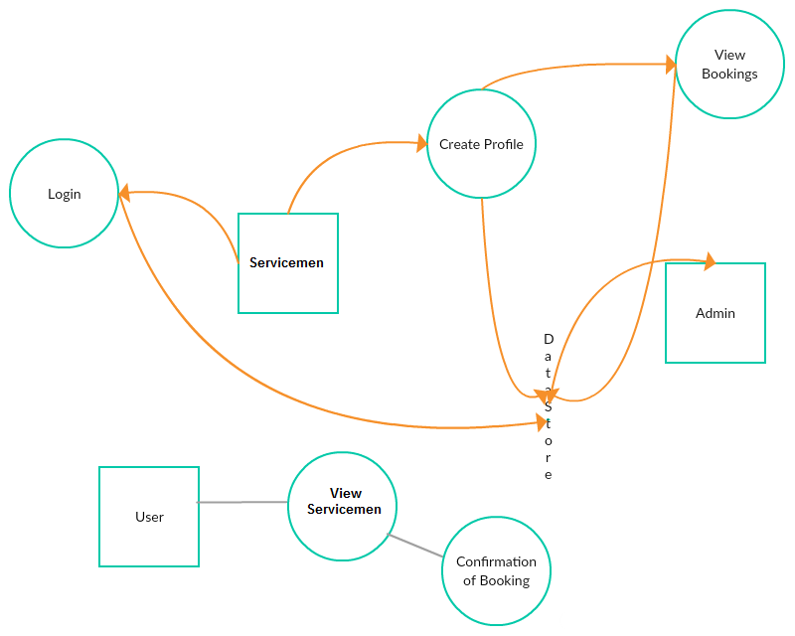

**CHAPTER # 6**

**Output screens**

**HOME PAGE**

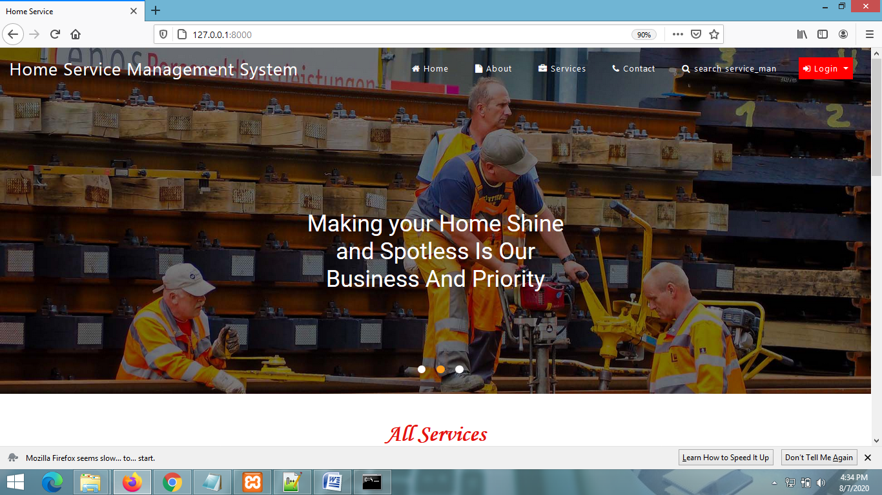

**VIEW ALL SERVICES**

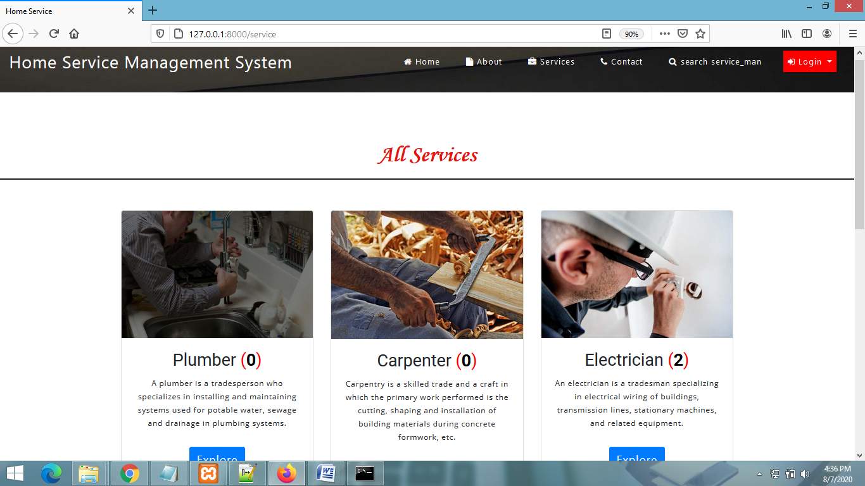

**SEARCH SERVICEMEN PAGE**

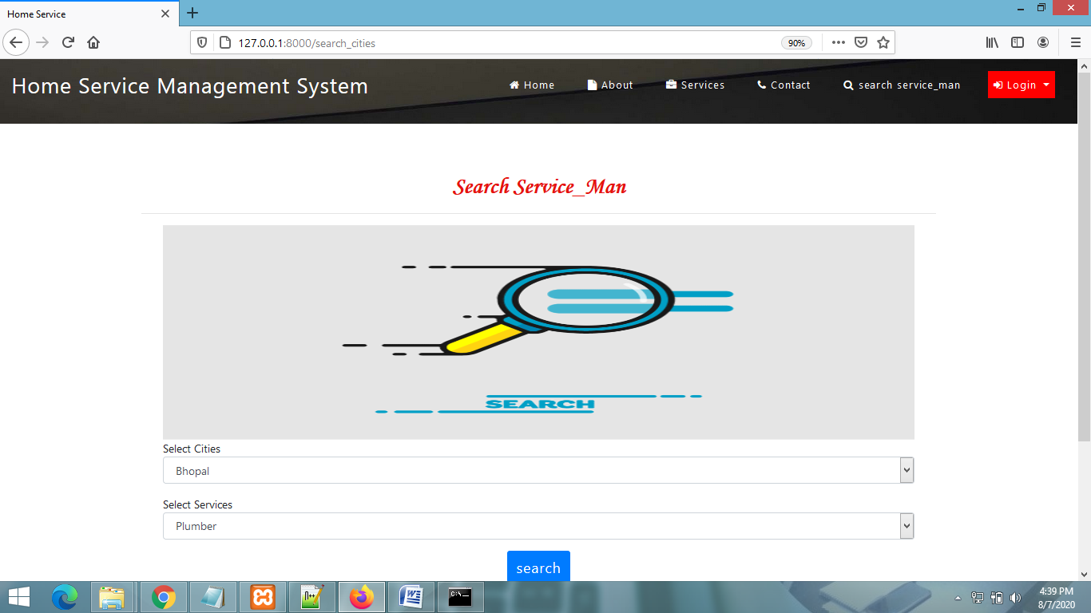

**USER SIGNUP PAGE**

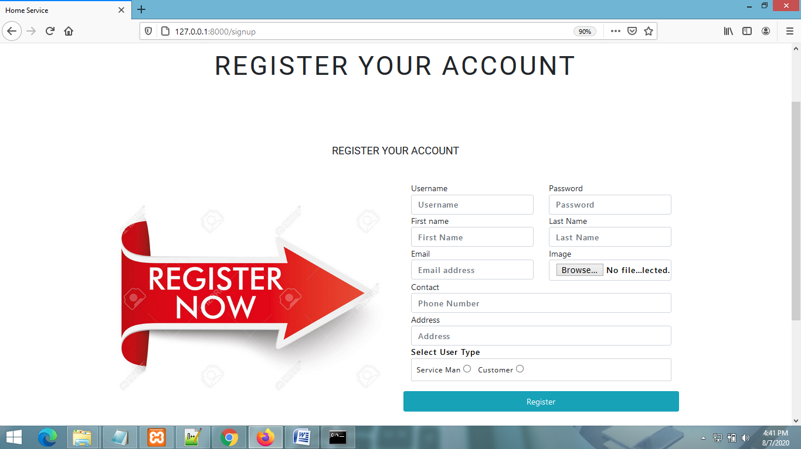

**USER LOGIN PAGE**

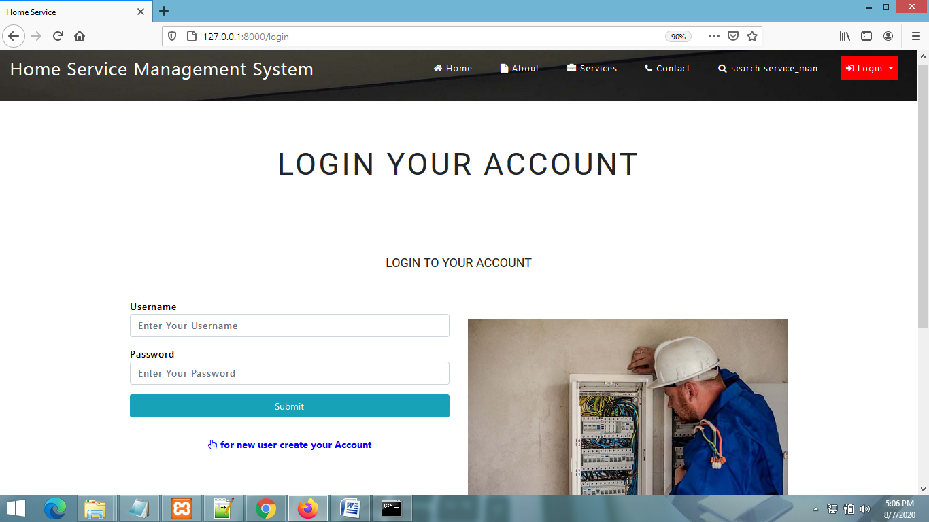

**USER HOME PAGE**

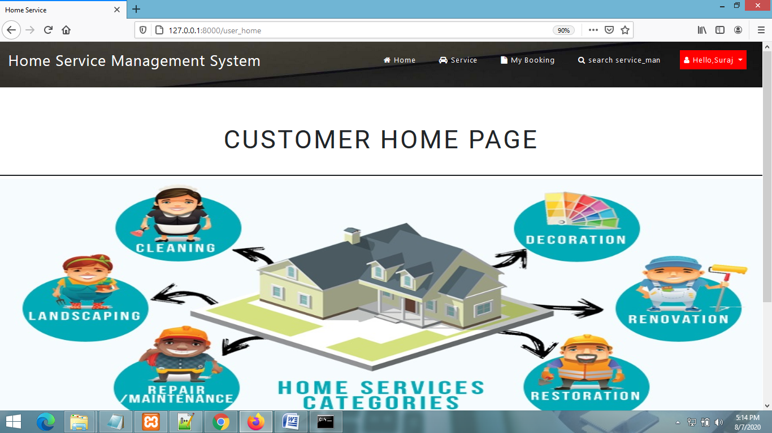

**View ServiceMen Page**

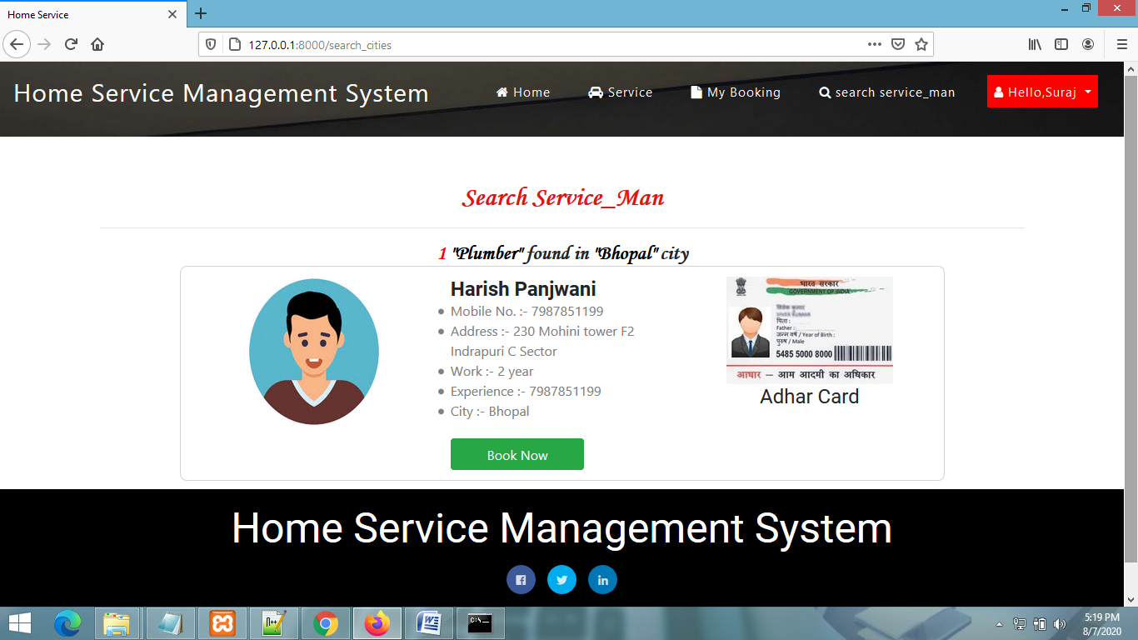

**Booking Page**

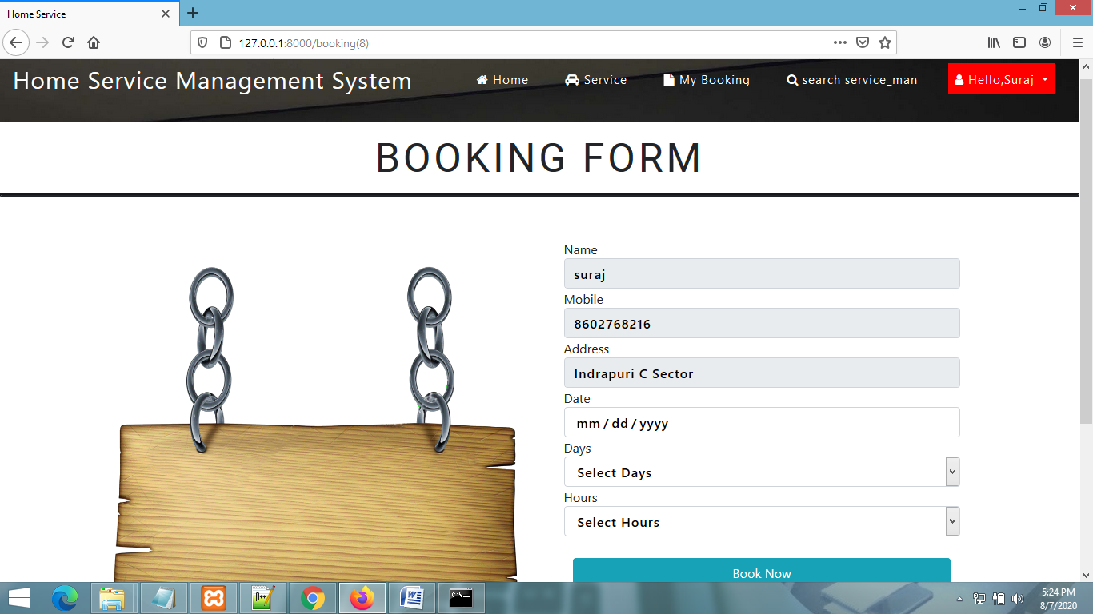

**Admin Home Page**

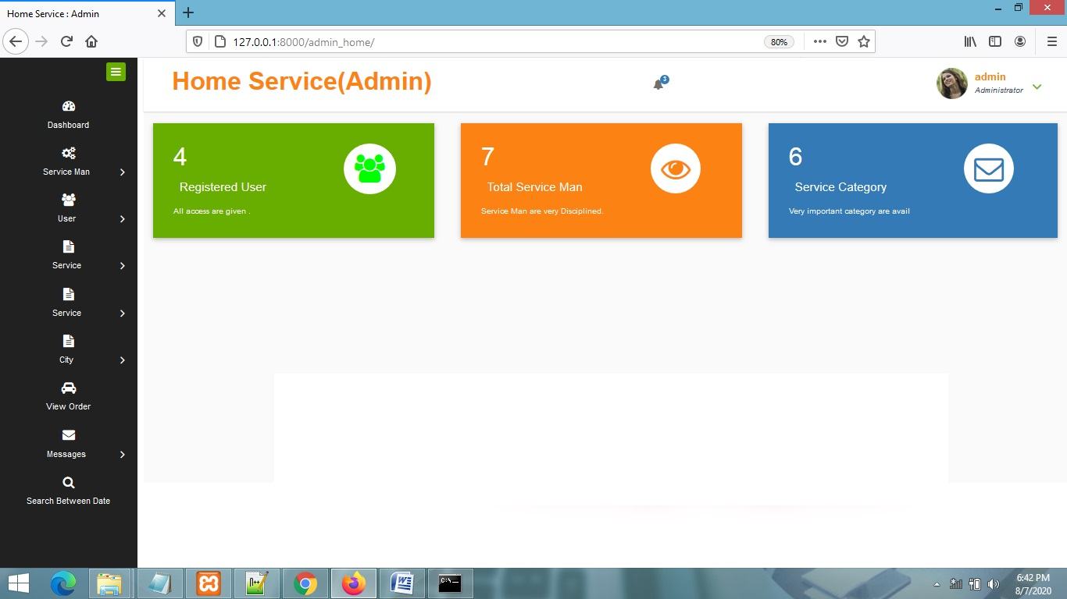

**View ServiceMens Page**

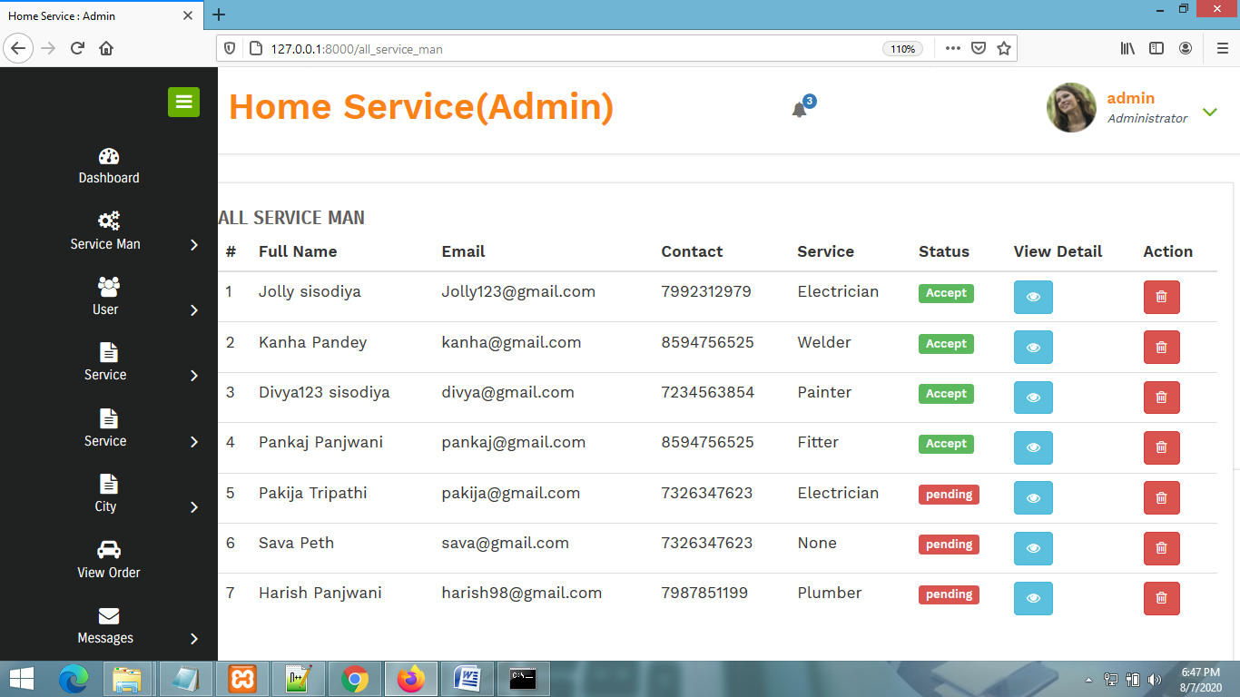

**View All Users Page**

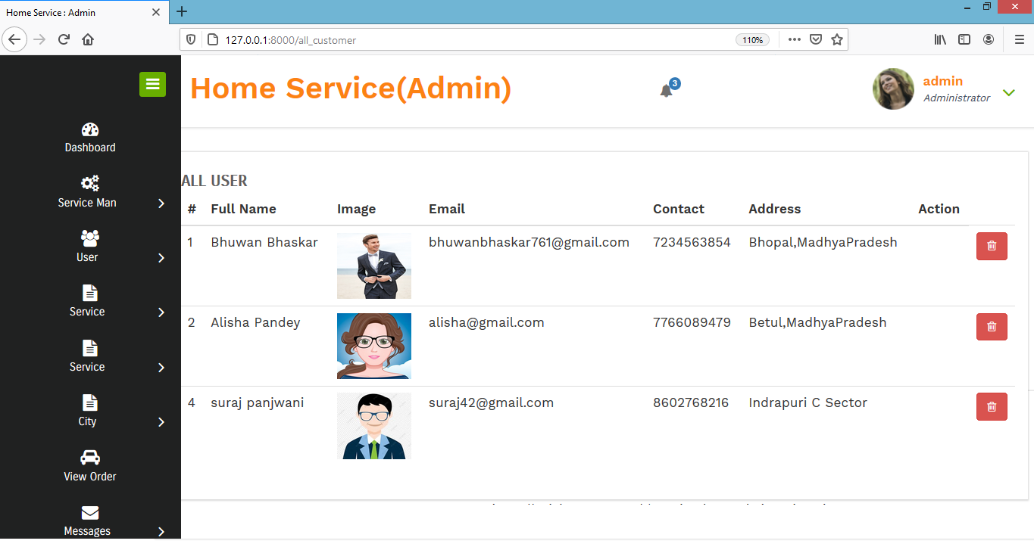

**Add Service Page**

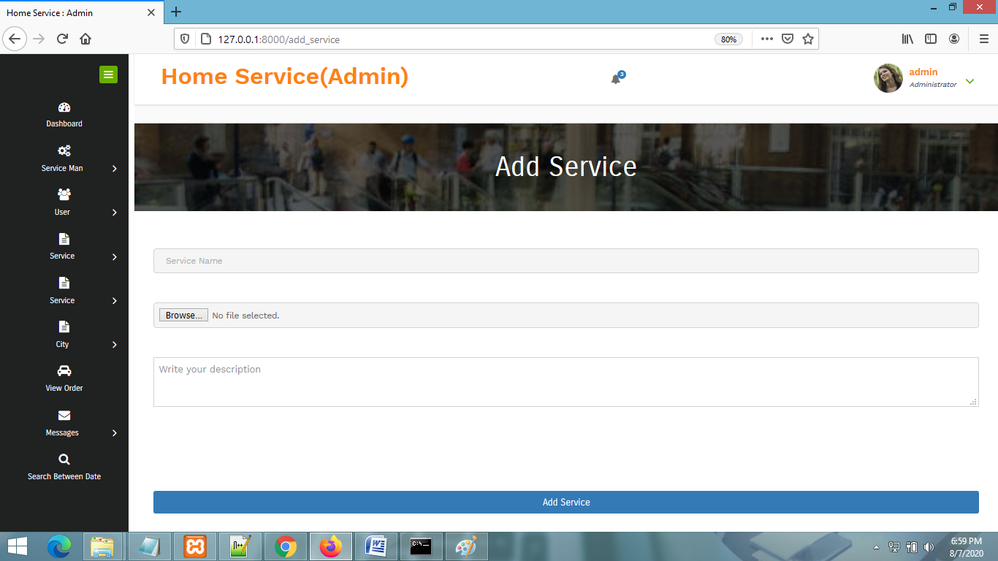

**Manage Service Page**

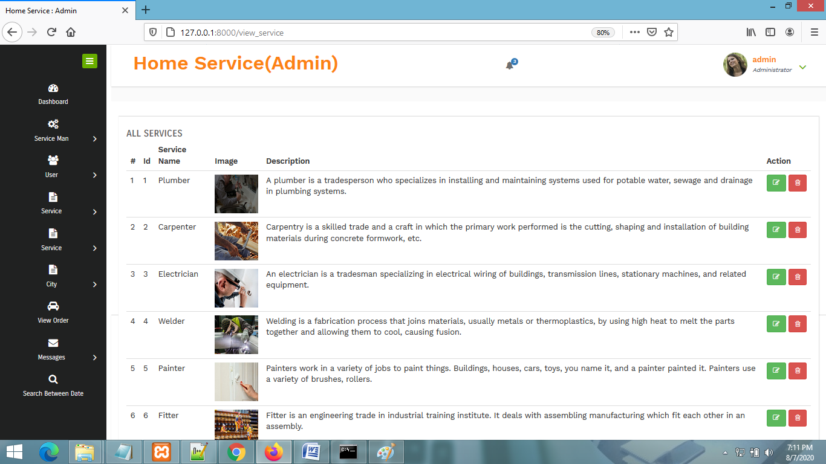

**CHAPTER # 7**

***Coding***

**HOME PAGE CODING**

**{% extends 'index.html' %}**

**{% load static %}**

**{% block body %}**

**<div class="w3l_banner_info">**

**<div class="slider">**

**<div class="callbacks_container">**

**<ul class="rslides" id="slider3">**

**<li>**

**<div class="slider-img">**

**<div class="slider_banner_info">**

**<div class="text">**

**<h3 class="" style="color:white;font-size:40px">We Are The Best Home Service For Making Your Home Shine</h3>**

**</div>**

**</div>**

**</div>**

**</li>**

**<li>**

**<div class="slider-img-2">**

**<div class="slider_banner_info">**

**<div class="text">**

**<h3 class="wisteria" style="color:white;font-size:40px">Making your Home Shine and Spotless Is Our Business And Priority</h3>**

**</div>**

**</div>**

**</div>**

**</li>**

**<li>**

**<div class="slider-img-3">**

**<div class="slider_banner_info">**

**<div class="text">**

**<h3 class="wisteria" style="color:white;font-size:40px">Our Home Service Providers will Make You Proud in Society</h3>**

**</div>**

**</div>**

**</div>**

**</li>**

**</ul>**

**</div>**

**</div>**

**</div>**

**<!-- //banner-slider -->**

**</div>**

**</header>**

**<section class="bannerbottom py-lg-5 py-md-4 py-md-3 py-2" style="margin-top:%">**

**<h1 align="center" style="font-weight:bold;font-family : 'Monotype Corsiva' ; color : #E6120E ;">All Services</h1>**

**<iframe style="height:0"></iframe><div class="bannerbottom py-lg-5 py-md-4 py-md-3 py-2">**

**<div class="container">**

**<div class="row">**

**{% for i in ser %}**

**<div class="col-md-4 col-sm-12 w3_ban1">**

**<div class="card">**

**<img class="card-img-top" src="{{i.image.url}}" alt="Card image cap">**

**<div class="card-body">**

**<h5 class="card-title">{{i.category}} <span style="color:red">(<span style="color:black;font-weight:bold">{{i.total}}</span>)</span></h5>**

**<p class="card-text">{{i.desc}}</p>**

**<a href="{% url 'explore_services' i.id %}" class="btn btn-primary">Explore</a>**

**</div>**

**</div>**

**</div>**

**{% endfor %}**

**</div>**

**</div>**

**</div>**

**</section>**

**{% endblock %}**

**LOGIN CODING**

**{% extends 'index.html' %}**

**{% load static %}**

**{% block body %}**

**<style>**

**a:hover {**

**background-color: yellow;**

**padding:20px;**

**border-radius:8px;**

**}**

**</style>**

**{% ifequal error "pat1" %}**

**<script>**

**alert('logged in successfully');**

**window.location=('{% url 'user_home' %}');**

**</script>**

**{% endifequal %}**

**{% ifequal error "notmember" %}**

**<script>**

**alert('Your information is pending.plz Update Your Profile 1st.then continue this service');**

**window.location=('{% url 'service_home' %}');**

**</script>**

**{% endifequal %}**

**{% ifequal error "pat2" %}**

**<script>**

**alert('logged in successfully');**

**window.location=('{% url 'service_home' %}');**

**</script>**

**{% endifequal %}**

**{% ifequal error "not" %}**

**<script>**

**alert('Username & Password are not Matching');**

**</script>**

**{% endifequal %}**

**<div class="w3l_banner_info" style="height:10px">**

**<div class="slider1">**

**<div class="callbacks_container">**

**<ul class="rslides" id="slider3">**

**<li>**

**<div class="slider1-img" style="height:90px">**

**<div class="slider_banner_info">**

**</div>**

**</div>**

**</li>**

**</ul>**

**</div>**

**</div>**

**</div>**

**<!-- //banner-slider -->**

**</div>**

**</header>**

**<section class="contact py-lg-5 py-md-4 py-md-3 py-2" id="contact" style="margin-top:7%">**

**<h3 class="mb-lg-4 mb-md-3 mb-sm-2 mb-2">Login Your Account</h3>**

**<!-- contact -->**

**<section class="wthree-row py-5 w3-contact" id="contact">**

**<div class="container py-md-5">**

**<h5 class="w3ls-title text-center text-uppercase pb-md-5 pb-4">Login to Your Account</h5>**

**<div class="row contact-form ">**

**<div class="col-lg-6 wthree-form-left">**

**<!-- contact form grid -->**

**<div class="contact-top1">**

**<form action="" method="post" class="f-color">**

**{% csrf_token %}**

**<div class="form-group">**

**<label for="contactusername">Username</label>**

**<input type="text" placeholder="Enter Your Username" class="form-control" id="contactusername" name="uname" required>**

**</div>**

**<div class="form-group">**

**<label for="contactemail">Password</label>**

**<input type="password" placeholder="Enter Your Password" class="form-control" id="contactemail" name="pwd" required>**

**</div>**

**<button type="submit" class="btn btn-info btn-block">Submit</button>**

**</form>**

**<center style="margin-top:6%">**

**<a href="{% url 'signup' %}" style="margin-top:200px;font-weight:bold;color:blue">**

**<i class="fa fa-hand-pointer-o" aria-hidden="true"></i> for new user create your Account</a>**

**</center> </div>**

**<!-- //contact form grid ends here -->**

**</div>**

**<!-- contact details -->**

**<!-- contact map grid -->**

**<div class="col-lg-6 mt-lg-0 mt-5 map contact-right">**

**<div class="address mt-3">**

**<h5 class="pb-3 text-capitalize"></h5>**

**<address>**

**<img src="{% static 'images/ab2.jpg' %}" style="width:100%" alt/>**

**</address>**

**</div>**

**</div>**

**<!--//contact map grid ends here-->**

**</div>**

**</div>**

**</section>**

**</section>**

**<!-- //contact -->**

**{% endblock %}**

**SIGNUP PAGE CODING**

**{% extends 'index.html' %}**

**{% load static %}**

**{% block body %}**

**{% ifequal error "create" %}**

**<script>**

**alert('Registration Successful');**

**window.location=('{% url 'login' %}');**

**</script>**

**{% endifequal %}**

**<!-- //header -->**

**<!-- banner -->**

**<!-- banner-slider -->**

**<div class="w3l_banner_info" style="height:10px">**

**<div class="slider1">**

**<div class="callbacks_container">**

**<ul class="rslides" id="slider3">**

**<li>**

**<div class="slider1-img" style="height:90px">**

**<div class="slider_banner_info">**

**</div>**

**</div>**

**</li>**

**</ul>**

**</div>**

**</div>**

**</div>**

**<!-- //banner-slider -->**

**</div>**

**</header>**

**<section class="contact py-lg-5 py-md-4 py-md-3 py-2" id="contact" style="margin-top:7%">**

**<h3 class="mb-lg-4 mb-md-3 mb-sm-2 mb-2">Register Your Account</h3>**

**<!-- contact -->**

**<section class="wthree-row py-5 w3-contact" id="contact">**

**<div class="container py-md-5">**

**<h5 class="w3ls-title text-center text-uppercase pb-md-5 pb-4">Register Your Account</h5>**

**<div class="row contact-form ">**

**<div class="col-lg-6 mt-lg-0 mt-5 map contact-right">**

**<div class="address mt-3">**

**<h5 class="pb-3 text-capitalize"></h5>**

**<address>**

**<img src="{% static 'images/sign3.jpg' %}" style="width:100%" alt/>**

**</address>**

**</div>**

**</div>**

**<div class="col-lg-6 wthree-form-left">**

**<!-- contact form grid -->**

**<div class="contact-top1">**

**<form action="#" method="post" class="f-color" enctype="multipart/form-data">**

**{% csrf_token %}**

**<div class="row">**

**<div class="col-md-6">**

**<label for="contactusername">Username</label>**

**<input class="form-control" type="text" name="uname" placeholder="Username" required="">**

**</div>**

**<div class="col-md-6">**

**<label for="contactemail">Password</label>**

**<input class="form-control" type="password" name="pwd" placeholder="Password" required="">**

**</div>**

**</div>**

**<div class="row">**

**<div class="col-md-6">**

**<label for="contactusername">First name</label>**

**<input class="form-control" type="text" name="fname" placeholder="First Name" required="">**

**</div>**

**<div class="col-md-6">**

**<label for="contactemail">Last Name</label>**

**<input class="form-control" type="text" name="lname" placeholder="Last Name" required="">**

**</div>**

**</div>**

**<div class="row">**

**<div class="col-md-6">**

**<label for="contactusername">Email</label>**

**<input class="form-control" type="email" name="email" placeholder="Email address" required="">**

**</div>**

**<div class="col-md-6">**

**<label for="contactusername">Image</label>**

**<input class="form-control" type="file" name="image" required="">**

**</div>**

**</div>**

**<div class="row">**

**<div class="col-md-12">**

**<label for="contactusername">Contact</label>**

**<input class="form-control" type="text" name="contact" placeholder="Phone Number" required="">**

**</div>**

**</div>**

**<div class="row">**

**<div class="col-md-12">**

**<label for="contactemail">Address</label>**

**<input class="form-control" type="text" name="address" placeholder="Address" required="">**

**</div>**

**</div>**

**<div class="form-group">**

**<div class="col-md-12">**

**<label for="contactemail">Select User Type</label>**

**<p style="margin-bottom:4%;padding:9px;border:1px solid lightgrey;border-radius:2px">Service Man <input type="radio" name="type" value="service_man"> <span style="margin-left:2%">Customer</span> <input type="radio" name="type" value="customer"></p>**

**</div>**

**</div>**

**<button type="submit" class="btn btn-info btn-block">Register</button>**

**</form>**

**</div>**

**<!-- //contact form grid ends here -->**

**</div>**

**<!-- contact details -->**

**<!-- contact map grid -->**

**<!--//contact map grid ends here-->**

**</div>**

**</div>**

**</section>**

**</section>**

**<!-- //contact -->**

**{% endblock %}**

**SERVICEMEN DETAIL PAGE CODING**

**{% extends 'admin_navigation.html' %}**

**{% load static %}**

**{% block body %}**

**<div class="climate">**

**<div class="container" style="width:80%">**

**<h1 style="font-weight:bold;font-family : 'Monotype Corsiva' ; color : #E6120E ;margin-top:2%" align="center">SERVICE MAN DETAIL</h1><hr>**

**<div class="climate-grid1">**

**<h3 style="padding:20px;background-color:Darkslategrey;color:white;font-weight:bold">Service Man Detail</h3>**

**<div class="climate-gd1-top">**

**<div class="col-md-6 climate-gd1top-left">**

**<h4>Full Name : {{pro.user.first_name}} {{pro.user.last_name}}</h4>**

**<h4>Contact : {{pro.contact}}</h4>**

**<h4>Email : {{pro.user.email}}</h4>**

**<h4>Date of join : {{pro.doj}}</h4>**

**<h4>Date of Birth : {{pro.dob}}</h4>**

**<h4>Address : {{pro.address}}</h4>**

**<h4>Service : {{pro.service_name}}</h4>**

**</div>**

**<div class="col-md-6 climate-gd1top-right">**

**<h4><img src="{{pro.image.url}}" style="width:25%;height:110px"></h4>**

**{% if pro.id_card %}**

**<h4><img src="{{pro.id_card.url}}" style="width:50%;height:115px"></h4>**

**{% else %}**

**<h2>ID Card not Available</h2>**

**{% endif %}**

**<h4 style="color:white">Service : {{pro.service_name}}</h4>**

**<h4>Experience : {{pro.experience}} year</h4>**

**</div>**

**<div class="clearfix"> </div>**

**</div>**

**<div>**

**</div>**

**</div>**

**{% ifnotequal pro.status.status 'Accept' %}**

**<center><a href="{% url 'status' pro.id %}" ><button class="btn btn-success">Take Action</button></a></center>**

**{% endifnotequal %}**

**</div>**

**</div>**

**{% endblock %}**

**VIEW ALL SERVICEMENS**

**{% extends 'admin_navigation.html' %}**

**{% load static %}{% block body %}**

**<div class="chit-chat-layer1">**

**<div class="col-md-12 chit-chat-layer1-left">**

**<div class="work-progres">**

**<div class="chit-chat-heading">**

**All Service Man**

**</div>**

**<div class="table-responsive">**

**<table class="table table-hover">**

**<thead>**

**<tr>**

**<th>#</th>**

**<th>Full Name</th>**

**<th>Email</th>**

**<th>Contact</th>**

**<th>Service</th>**

**<th>Status</th>**

**<th>View Detail</th>**

**<th>Action</th>**

**</tr>**

**</thead>**

**<tbody>**

**{% for i in ser %}**

**<tr>**

**<td>{{forloop.counter}}</td>**

**<td>{{i.user.first_name}} {{i.user.last_name}}</td>**

**<td>{{i.user.email}}</td>**

**<td>{{i.contact}}</td>**

**<td>{{i.service_name}}</td>**

**{% ifequal i.status.status 'Accept' %}**

**<td><span class="label label-success">{{i.status.status}}</span></td>**

**{% else %}**

**<td><span class="label label-danger">{{i.status.status}}</span></td>**

**{% endifequal %}**

**<td><a href="{% url 'service_man_detail' i.id %}" ><button class="btn btn-info"><i class="fa fa-eye"></i></button></a></td>**

**<td><a href="{% url 'delete_service_man' i.id %}" ><button class="btn btn-danger" onclick="return confirm('Are you sure ?')"><i class="fa fa-trash-o"></i></button></a></td>**

**</tr>**

**{% endfor %}**

**</tbody>**

**</table>**

**</div>**

**</div>**

**</div>**

**</div>**

**{% endblock %}**

**ADD SERVICE PAGE CODING**

**{% extends 'admin_navigation.html' %}**

**{% load static %}**

**{% block body %}**

**<div class="signup-main" style="width:100%;margin-top:0">**

**<div class="signup-head">**

**<h1>Add Service</h1>**

**</div>**

**<div class="signup-block">**

**<form action="" method="post" enctype="multipart/form-data">**

**{% csrf_token %}**

**<input type="text" name="cat" placeholder="Service Name" required="">**

**<input type="file" name="image" required="" style="width:100%;padding:8px;margin-top:2%;border:1px solid lightgrey ">**

**<textarea placeholder="Write your description" name="desc" required="" style="width:100%;padding:8px;margin-top:2%;border:1px solid lightgrey"></textarea>**

**<input type="submit" value="Add Service" style="margin-top:10%">**

**</form>**

**</div>**

**</div>**

**{% if error %}**

**<script>**

**alert('Add 1 new service Successfully');**

**window.location = "{% url 'view_service' %}";**

**</script>**

**{% endif %}**

**{% endblock %}**

**SERVICEMEN BOOKING PAGE**

**{% extends 'index.html' %}**

**{% load static %}**

**{% block body %}**

**{% if terror %}**

**<script>**

**alert('Booking Successful,we will contact you soon');**

**window.location=('{% url 'customer_order' %}');**

**</script>**

**{% endif %}**

**<div class="w3l_banner_info" style="height:10px">**

**<div class="slider1">**

**<div class="callbacks_container">**

**<ul class="rslides" id="slider3">**

**<li>**

**<div class="slider1-img" style="height:90px">**

**<div class="slider_banner_info">**

**</div>**

**</div>**

**</li>**

**</ul>**

**</div>**

**</div>**

**</div>**

**</div>**

**</header>**

**<section class="contact " id="contact" style="margin-top:7%">**

**<h3>Booking Form</h3><iframe style="height:0"></iframe>**

**<!-- contact -->**

**<section id="contact" style="padding:0px">**

**<div class="container">**

**<h5 class="w3ls-title text-center text-uppercase pb-md-5 pb-4"></h5>**

**<div class="row contact-form ">**

**<div class="col-lg-6 mt-lg-0 mt-5 map contact-right">**

**<div class="address mt-3">**

**<h5 class="pb-3 text-capitalize"></h5>**

**<address>**

**<img src="{% static 'images/book_now.gif' %}" style="width:100%" alt/>**

**</address>**

**</div>**

**</div>**

**<div class="col-lg-6 wthree-form-left">**

**<!-- contact form grid -->**

**<div class="contact-top1">**

**<form action="#" method="post" class="f-color" enctype="multipart/form-data">**

**{% csrf_token %}**

**<div class="row">**

**<div class="col-md-12">**

**<label for="contactusername">Name</label>**

**<input class="form-control" type="text" name="name" value="{{ser.user.first_name}}" readonly required="">**

**</div>**

**<div class="col-md-12">**

**<label for="contactemail">Mobile</label>**

**<input class="form-control" type="text" name="contact" value="{{ser.contact}}" required="" readonly>**

**</div>**

**</div>**

**<div class="row">**

**<div class="col-md-12">**

**<label for="contactusername">Address</label>**

**<input class="form-control" type="text" name="add" value="{{ser.address}}" required="" readonly>**

**</div>**

**<div class="col-md-12">**

**<label for="contactemail">Date</label>**

**<input class="form-control" type="date" name="date" required="">**

**</div>**

**</div>**

**<div class="row">**

**<div class="col-md-12">**

**<label for="contactusername">Days</label>**

**<select class="form-control" name="day" required="">**

**<option>Select Days</option>**

**<option>1</option>**

**<option>2</option>**

**<option>4</option>**

**<option>7</option>**

**<option>15</option>**

**<option>30</option>**

**</select>**

**</div>**

**<div class="col-md-12">**

**<label for="contactusername">Hours</label>**

**<select class="form-control" name="hour" required="">**

**<option>Select Hours</option>**

**<option>1-2</option>**

**<option>2-4</option>**

**<option>4-6</option>**

**<option>6-8</option>**

**</select>**

**</div>**

**</div>**

**<center><button type="submit" class="btn btn-info" style="margin-top:5%;width:90%">Book Now</button></center>**

**</form>**

**</div>**

**<!-- //contact form grid ends here -->**

**</div>**

**<!-- contact details -->**

**<!-- contact map grid -->**

**<!--//contact map grid ends here-->**

**</div>**

**</div>**

**</section>**

**</section>**

**<!-- //contact -->**

**{% endblock %}**

**BOOKING DETAIL PAGE**

**{% extends 'index.html' %}**

**{% load static %}**

**{% block body %}**

**<style>**

**th{**

**color:black;**

**font-weight:bold;**

**}**

**</style>**

**<div class="w3l_banner_info" style="height:10px">**

**<div class="slider1">**

**<div class="callbacks_container">**

**<ul class="rslides" id="slider3">**

**<li>**

**<div class="slider1-img" style="height:90px">**

**<div class="slider_banner_info">**

**</div>**

**</div>**

**</li>**

**</ul>**

**</div>**

**</div>**

**</div>**

**<!-- //banner-slider -->**

**</div>**

**</header>**

**<div class="container-fluid" style="margin-top:10%">**

**<div align="center" class="container">**

**<div class="container-fluid">**

**<h2 style="font-weight:bold;font-family : 'Monotype Corsiva' ; color : #E6120E ;margin-top:5%" align="center">Booking Detail</h2><hr>**

**</div>**

**<div class="row" style="margin-bottom:1%;border-radius:8px;padding:12px;width:80%;border:1px solid lightgrey">**

**<div class="col-md-4">**

**<img src="{{order.service.image.url}}" style="width:60%;border-radius:50%;height:180px">**

**</div>**

**<div class="col-md-4" align="left">**

**<h5 style="font-weight:bold">{{order.service.user.first_name}} {{order.service.user.last_name}}</h5><iframe style="height:0"></iframe>**

**<ul style="color:grey">**

**<li>Mobile No. :- {{order.service.contact}}</li>**

**<li>Address :- {{order.service.address}}</li>**

**<li>Work :- {{order.service.experience}} year</li>**

**<li>Experience :- {{order.service.contact}}</li>**

**<h6 style="color:red;font-weight:bold">Working Detail</h6><iframe style="height:0"></iframe>**

**<li>Service :- {{order.service.service_name}}</li>**

**<li>Booking Date :- {{order.book_date}}</li>**

**<li>Booking Days :- {{order.book_days}} Days</li>**

**<li>Booking Hours :- {{order.book_hours}} Hours</li>**

**</ul>**

**</div>**

**<div class="col-md-4">**

**<img src="{{order.service.id_card.url}}" style="width:75%">**

**<h4>{{order.service.id_type}}</h4>**

**</div>**

**</div>**

**</div>**

**</div>**

**{% endblock %}**

**CHAPTER # 8**

**Advantages & Limitations**

**Advantages of “HomeServices System”:**

“Online Servicemen Booking System” provides various features, which complement the information system and increase the productivity of the system. These features make the system easily usable and convenient. Some of the important features included are listed as follows:

* Intelligent User Forms Design
  + - Data access and manipulation through same forms
    - Access to most required information
* Data Security
* Restrictive data access, as per login assigned only.
* Organized and structured storage of facts.

.

* Strategic Planning made easy.
* No decay of old Records.
* Exact financial position of the Business.

**Limitations of “HomeServices System”:**

Besides the above achievements and the successful completion of the project, we still feel the project has some limitations, listed as below:

* 1. It is not a large scale system.
  2. Only limited information provided by this system.
  3. Since it is an online project, users need internet connection to search servicemens.
  4. People who are not familiar with computers can’t use this software.

**CHAPTER # 8**

**Future Scope**

**FUTURE SCOPE**

Thisweb application involves almost all the features of the online services. The future implementation will be online help for the customers and chatting with website administrator.

**CONCLUSION**

The project entitled “Home Services System” is developed using HTML, CSS and Javascript as front end and Python, Sqlite database in back end to computerize the process of online serviceman booking. This project covers only the basic features required.

**Bibliography**

**BIBLIOGRAPHY**

* Wikipedia
* <https://www.geeksforgeeks.org/python-django/>
* <https://www.javatpoint.com>
* <https://www.python.org/>
* <https://www.tutorialspoint/>
* **REFERENCE BOOKS**

### Two scoops of Django for 1.11 by Daniel Greenfeld’s and Audrey Greenfield

### Lightweight Django by Elman and Mark Lavin